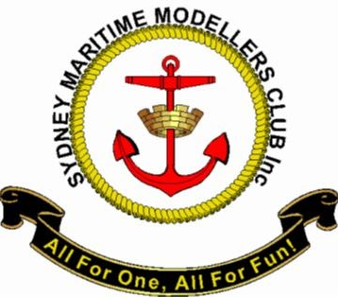
Application for Membership
Sydney Maritime Modellers Club
Name:
Address:
Post Code:
Phone:
Emergency Contact No. …………….…………………………………………………… (For Medical Emergency only)
E Mail: (Privacy Policy Applies See Website)
Date:

Signed: .........................................
If current member name of another Radio Yachting Club please detail: ………………………………………
Membership type: (Annual)
Come to the Lake on Saturday and Get Nominated
Nominated By: .................................................................................................
Date: .........................................
Signature: .....................................................................................

Seconder: ..........................................................................................................
Date: .........................................
Signature: ......................................................................................
Fees (once membership approved)
Joining Fee ($15), Annual Membership Full $45, If a current Member of NSW Affiliated RCY club $30.

Approved by Meeting of Committee Date: …………………………………………………….
Club Information is available on http://smmc1998.weebly.com/

